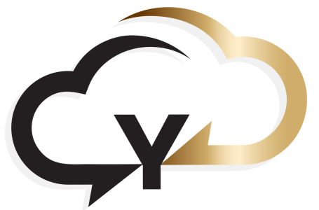

6 Signs You've Outgrown Your Phone System
For many small and medium-sized businesses, the phone system is the backbone of daily operations. Yet, as companies grow, what once worked fine can suddenly become a bottleneck — affecting productivity, customer experience, and even revenue. Here are six clear signs your business has outgrown its current phone system.
1. Missed Calls Are Becoming the Norm
If customers or clients frequently reach voicemail or your team struggles to answer every call, your phone system may not be keeping up. Missed calls can directly affect sales, reputation, and customer trust. Modern phone systems offer call routing, auto-attendants, and mobile apps to ensure no call goes unanswered.
2. Lack of Reporting and Insights
A simple phone line tells you who called, but not much else. If you can’t track call volume, response times, or identify which campaigns drive calls, you’re missing vital business intelligence. Advanced systems provide call analytics, dashboards, and recording features to help managers make informed decisions.
3. Remote and Hybrid Working Is a Challenge
Traditional systems often tie employees to a desk. If your staff work remotely or split time between home and office, an inflexible system will hurt productivity. Cloud-based phone solutions let employees make and receive calls from anywhere, on any device, while keeping everything integrated.
4. Integrations Are Non-Existent
Modern businesses rely on CRM, helpdesk, and other software platforms. If your phone system can’t integrate with these tools, your team is forced into manual processes, which can cause mistakes, missed opportunities, and inefficiencies.
5. You’re Constantly Paying for Maintenance or Upgrades
Older on-premise systems require frequent maintenance, costly upgrades, and hardware replacements. If you’re spending more on keeping your system alive than it’s worth, it’s time to consider a scalable, cloud-hosted solution that grows with your business.
6. Your Phone System Is Too Fancy for Your Needs
Sometimes the problem isn’t a lack of features — it’s having too many. If your system includes advanced call centre software, complex IVRs, or reporting tools that your small team never uses, it can slow operations, confuse staff, and drive unnecessary costs. The right phone system should fit your team’s workflow, not overwhelm it.
Final Thought
Outgrowing your phone system is a natural part of business growth — whether it’s too simple or too complex. Upgrading to a solution that’s flexible, user-friendly, and aligned with your business needs improves customer experience, boosts team efficiency, and gives you actionable insights to drive growth.

